A Project report on
“ INTELLIGENT INDOOR AIR QUALITY(IAQ)MONITORING AND FORECASTING SYSTEM”
Submitted in partial fulfilment of the requirement for the award of the degree of
BACHELOR OF TECHNOLOGY
IN
COMPUTER SCIENCE AND ENGINEERING
Submitted by
T.VIJAYA MARY 22X51A05E7
U.HEMALATHA 22X51A05E9
P.SWATHI 22X51A05G2
K.SUVARSHA 23X55A0505
V.MALLESWARI 22X51A05F2

Under the Esteemed Guidance of
Ms. S. Nazia Banu, Msc, M. Tech.
Assistant Professor, CSE Department



DEPARTMENT OF COMPUTER SCIENCE AND ENGINEERING
SANTHIRAM ENGINEERING COLLEGE::NANDYAL
(Autonomous)
(Approved by AICTE, New Delhi: Affiliated to J.N.T. University, Anantapuramu, A.P.) Accredited by NAAC (Grade-A), Accredited by NBA(ECE&CSE)
An ISO 9001:2015 Certified Institution, 2(f) and 12(b) recognition by UGC Act, 1956
Web: www.srecnandyal.edu.in
YEAR: 2022-2026
SANTHIRAM ENGINEERING COLLEGE::NANDYAL
(Autonomous)
(Approved by AICTE, New Delhi: Affiliated to J.N.T. University, Anantapuramu, A.P.) Accredited by NAAC (Grade-A), Accredited by NBA(ECE&CSE)
An ISO 9001:2015 Certified Institution, 2(f) and 12(b) recognition by UGC Act, 1956 Web: www.srecnandyal.edu.in



CERTIFICATE
This is to certify that the dissertation entitled “INTELLIGENT INDOOR AIR QUALITY (IAQ)
MONITORING AND FORECASTING SYSTEM” is being submitted by T.VIJAYA MARY(22X51A05E7),U.HEMALATHA(22X51A05E9),P.SWATHI(22X51A05G2),K.SUVA
RSHA(23X55A0505),V.MALLESWARI(22X51A05F2) fulfilment of the award of the Degree of Bachelor of Technology in COMPUTER SCIENCE AND ENGINEERING in the SANTHIRAM ENGINEERING COLLEGE, Nandyal (Affiliated to J.N.T. University,
Anantapur) is a record of bonafide work carried out by her under our guidance and supervision. The results embodied in this project have not been submitted to any other university for the award of any Degree.

Signature of the Head of the Department: | Signature of the Project Guide:
Dr.S.Md.FAROOQ, M.Tech,Ph.D,MISTE | Ms.S. Nazia Banu ,Msc, M.Tech.
Professor & HOD | Assistant Professor

Signature of the External Examiner:

Date of Examination:
ACKNOWLEDGEMENT

This will certainly not be complete without acknowledgements paid to all these who have helped us in doing our project work.
We manifest our heartier thankfulness pertaining to our contentment over Ms. S. Nazia Banu garu, as projects guide with whose adroit concomitance the excellence has been exemplified in bringing out this project work with artistry.
It is a great pleasure to acknowledge my profound sense of gratitude to our Head of Department Dr.S.MD.Farooq garu and Coordinator Mrs.V.Lakshmi Chaitanya garu for their valuable and inspiring guidance, comments and suggestions and encouragement towards the course of this project.
Involuntarily, We are very precious to divulge my sincere gratefulness to our principal Dr.M.V.Subramanyam garu, who has been observed posing valance in abundance forwards our individuality to acknowledge my project work tendentiously.
At the outset we thank to our Honorable chairman Dr.M.Santhiramudu garu, correspondent, Santhiram Engineering College for providing us with good facilities and his moral support throughout the course.
We wish to convey my gratitude and express sincere thanks to all P.R.C (Project Review Committee) members for their support and Co-operation rendered for successful submission of my project work.
We also express the overall exhilaration and gratitude to all the Teaching and Non- Teaching staff of CSE Dept. who admitted my project work and accentuated our attitude.
We also extend our heartfelt and sincere gratitude to my beloved parents for their tremendous motivation and moral support.

T.VIJAYA MARY
U.HEMALATHA
P.SWATHI
K.SUVARSHA
V.MALLESWARI

INDEX TABLE OF CONTENTS

S. NO DESCRIPTION Page No.
1. INTRODUCTION 1-4
1.1 Project Introduction 1
1.2 Motivation 2
1.3 Problem Statement 2 3
1.4 Objective 3
1.5 Scope 4
2. LITERATURE SURVEY 5 6
3. SYSTEM ANALYSIS 7 10

3.1 Existing System 7
3.2 Disadvantages 7
3.3 Proposed System 7-8
3.4 Project Flow 8
3.5 Algorithm 9-10
3.6 Advantages 10
- REQUIREMENT ANALYSIS 11-13
  - Functional and Nonfunctional Requirements 11-12
  - Hardware and Software Requirements 13
  - Architecture 14
- SYSTEM DESIGN 15-23
  - Input Design 15
  - Output Design 16
  - UML Diagrams 16
  - Use Case Diagram 16-17
  - Class Diagram 17
  - Sequence Diagram 18
  - Collaboration Diagram 18-19
  - Deployment Diagram 19
  - Component Diagram 19-20
  - Activity Diagram 20
  - ER Diagram 21
  - Data Flow Diagram 21-23
- IMPLEMENTATION AND RESULTS 24-40
  - Modules 24-26
  - AES Algorithm code 27-36
  - Steps for Executing the Projects 36
  - Results and Output Screens 37-40
- SYSTEM STUDY AND TESTING 41-46
  - Feasibility 41-42
7.1.1Economic Feasibility

7.1.2Technical Feasibility 7.1.3Social Feasibility
- 1.4System Testing
  - Testing 42-46
7.2.1 Unit Testing

7.2.2 Integration Testing 7.2.3 Functional Testing 7.2.4 White Box Testing 7.2.5 Black Box Testing
- CONCLUSION 47
- FUTURE ENHANCEMENTS 48
REFERENCES 49-50
ANNEXURE
i. Internship Certificates ii. Plagiarism Report of Documentation

LIST OF
FIGURES

S.NO NAME OF THE FIGURE PAGENO
  - 3.4 : Block Diagram of proposed system 8
  - 4.1 : System Architecture 14
  - 5.3.1: Use Case Diagram 17

5.3.2: Class Diagram
17
5.3.3: Sequence Diagram
18

5.3.4: Collaboration Diagram 19

5.3.5: Deployment Diagram
19
5.3.6: Component Diagram
20
5.3.7: Activity Diagram 20

5.3.8: ER Diagram 21
5.4: DFD Diagram
22
5.4.a: DFD Level-1 Diagram
22

5.4b: DFD Level-2 Diagram
23
  - 6.4a: Registration Page
37
6.4b: Login Page
37
6.4c: Home Page
38
6.4d: Upload Dataset
38
6.4e: Dataset Uploaded
39
6.4f: Prediction Page
39
6.4g: Result Page 40

ABSTRACT

Abstract: IAQ has been one of the most notable studies which have been carried to ensure the wellness and cognitive health of a population especially within an indoor social environment (hospitals, academic institutions). The project builds a particular paradigm of the automated smart IAQ monitoring and forecasting system and takes the environment sensing as referring to the IoT structure, CEP, and smart machine-learning techniques. Multi-purpose IoT devices (detection of multiple pollutants (CO2, PM2.5, TVOCs) and other environmental factors (temperature and humidity)) were custom-made in the University of Bath and placed in the surroundings of the office-lecture room area and also at Big-Field area. The two primary problems of predicting to the investigators, in turn, are the following: Predicting the air quality level (AQL) as a continuous value using regression, and predicting categories of the engulfment with AQL meaning by categories. Time-dependent learning is involved in such LSTM networks but regression learning of Accuracy Quotient (AQL) resulted in the best performance prediction results as the Random forest algorithm is capable of strong generalization in various situations. Decision Tree Classifier - classification was more superior than the other models since it offered numerous perceptions on patterns via identification of regulations which define the forms of pollution. The CEP engine assists in processing sensor streams and identifying abnormalities and acquisition of real-time clandestine pattern recognition. Swiftly by employing proper classification and interpretable forms of data selection systems, one may get proactive with relevance to the ventilation control as well as health safety determinations. It provides a scaffolding opportunity to have a scalable way-conscious building administration arrangement on ecological discovery, anticipatory analytics, and proactive insights.

The keywords will include: Air Quality Level, Indoor Air Quality, IoT Sensors, Regression, Classification, Decision tree, random forest, LSTM, PM2.5, CO 2, Complex Event Processing, AQL forecasting, Environmental analytics, Smart building.

1. INTRODUCTION

1.1 PROJECT INTRODUCTION:

Consequently, when such a large percentage of people are brought into academic building spaces, health care facilities, etc., IAQ becomes a part of human health, comfort, and productivity and host facilities occupied by the above-mentioned human tenants or humans. Due to this impact of the airborne pollution problem, therefore, there is a demand for systems that are able to time constrain real-time monitoring and analysis of the showcased IAQ services and quality to predict its rise. The proposal of the current research project is gaining an integrated IAQ monitoring and forecasting architecture, which will consider and facilitate such concerns by combining emerging new technologies such as IoT sensors, ML algorithms, CEP engines, etc.The IoT sensor network would be measuring a number of variables, namely: temperature, humidity, PM 2. 5 level, CO2 concentration and TVOCs. The known system then shows the updated data and implemented information about the state of indoor air quality after the acquisition and processed sensor data. These agricultural observations have two purposes in that, firstly, to help the stakeholders predict the air quality, based on regression models employed overtime, secondly to categorize air quality in categories previously established, which can provide mitigation advices that the stakeholders can follow to their benefit.Prediction needs to be done using the machine learning technique, which must be an accurate and interpretable method. The application of the LSTM model has been applied to both prediction of trend of the air pollution by forecasting of air quality in the time and to forecast of possible pollution as quickly as possible. For the classification, Decision Tree Classifier will provide us understandable and easy-to-read tree for air quality classification and we will get maximum regression accuracy with the Random Forest so that it is the way that the prediction will be as close to the actuality as possible. Due to this multi-functionality, the system is best suited to achieve very high accuracy for the different IAQ related applications.The project includes, in addition, a Complex Event Processing (CEP) engine for the analysis of streaming data in order to provide anomalies and unusual patterns on the fly. The system also provides giving away of a web-based dashboard featuring image depiction of real-time data and predictive analytics so that facility managers as healthcare administrators can then monitor these issues and take the appropriate actions. Scalability is taken into account since the design of the system and, in this respect, the extension to HVAC management, with automatic air regulation, is considered, so that it can be implemented in multiple buildings and, consequently, commercialized this smart IAQ monitoring system.

1.2 MOTIVATION:

The growing concerns around the adverse effects of poor indoor air quality on human health, cognitive performance, and overall well-being serve as the key motivation for this project. Urban environments, especially confined public spaces such as schools and hospitals, often lack dynamic monitoring systems capable of detecting air quality degradation in real time. Prolonged exposure to pollutants like PM2.5, CO₂, and TVOCs can lead to respiratory issues, fatigue, and long-term health complications. This project is driven by the need to develop an intelligent system that not only monitors but also predicts and classifies air quality, enabling timely and effective interventions. The integration of IoT sensors with machine learning presents a compelling solution for continuous environmental surveillance. LSTM models allow for the forecasting of AQL trends, which is vital for early warning systems. Decision Tree Classifiers offer transparent and interpretable categorization of pollution levels, while Random Forest excels at high-accuracy regression predictions. The inclusion of CEP ensures real-time pattern detection and anomaly alerts, thus enhancing system responsiveness. This multi-disciplinary approach exemplifies how AI and IoT can be harnessed to create smart, healthy, and sustainable building environments. By facilitating data-driven decisions on ventilation and occupancy management, the project aims to protect vulnerable populations and contribute to long-term public health improvement. The vision is to establish a proactive air quality management system that becomes a benchmark for smart building technology.

1.3 PROBLEM STATEMENT:

The indoor air pollution may be very dangerous to humankind and health, particularly to the dark places of the populace like hospitals, college and offices. The traditional way of air monitoring is mostly inert and reactive and share very little information and hence a reaction only when concentrations of pollutants are hazardous. They are spot-measurement systems in most cases since they do not provide any hint of the dynamic of the indoor air quality that endangers to postpone the problem-solving time and health hazard, especially in high density areas such as lecture halls or patient rooms.This paper opposes the above mentioned so-called weaknesses and develops a dynamic IAQ monitoring and predicting system both on the IoT architecture and that can be deployed to real-time monitoring as well as real-time prediction of the targeted parameter through the implementation of sensor-based systems coupled with machine learning algorithms. It is able to detect various environmental parameters, as well as predict the AQL level, and can categorize the air quality as in forms of Good, Moderate, Unhealthy etc. and anomalies in the indoor environment can be inferred in real time through complex event processing, and the anomalies can be rectified. Under such an intervention, the smart building will find support of the visionary building textiles and healthcare operators as much sought to guarantee safe occupancy and therefore provide proper comfort and overall fulfilment of occupancy in the indoor environment.

1.4 OBJECTIVE:

It is aimed to test the possibility of integrating and implementing the smart system of indoor air quality monitoring and prediction in the territories of the public buildings - hospitals and tertiary educational establishments. The system records the conditions of state of environment including temperature, relative humidity, particulate matter-2.5 (PM2.5), carbon dioxide (CO2), total volatile organic compounds (TVOCs) and so on, by the sensors of the IoT system. The prediction methods- machine learning are done through the data of air quality of all available sensors by the use of Decision Tree classifier where the classifier may be deployed to classify the air quality in the said categories of Air Quality viz., Good, Moderate or Unhealthy.There is also the system that is more predictable with numerical projections through Random Forests and where Complex Event Processing (CEP) is used to monitor anomalies or even changes in the quality of the air and immediate hypothesis is received as an instant real-time notation in case the thresholds are surpassed. The prediction and the classification are structured, making the leads to follow the system, being capable of developing just air quality management proactive, and enabling to develop building indoors is becoming a healthier and comfortable place in which occupants can enhance their health and energy, in addition to the fact that it provides the sustainable management of a building health with perennial and timely reaction.

1.5 SCOPE:
The scope of this project encompasses the end-to-end development of an intelligent Indoor Air Quality (IAQ) monitoring and forecasting system. This includes the deployment of IoT-based sensor networks capable of measuring environmental and pollutant parameters such as temperature, humidity, PM2.5, CO₂, and TVOCs. The data collected is preprocessed and analyzed using machine learning models to accomplish two primary tasks: regression-based forecasting of Air Quality Level (AQL) and classification of air quality into predefined categories. The LSTM model is used for predicting AQL trends over time, aiding early detection of pollution events. The Decision Tree Classifier is employed for interpretable categorization of pollution levels, while the Random Forest model is integrated for high-performance regression tasks. The system also incorporates a Complex Event Processing (CEP) engine to detect anomalies and patterns in real-time streaming data. Additionally, the scope includes the design of a web-based dashboard to visualize real-time data and predictions, providing actionable insights to stakeholders such as facility managers and healthcare administrators. The project covers model training, validation, and optimization using both synthetic and real- world datasets. It also considers future scalability, including integration with HVAC systems for automated air regulation and the possibility of deploying the system across multiple buildings. The scope excludes hardware-level manufacturing of sensors but assumes availability of compatible commercial sensors. In essence, this project aims to deliver a full-stack, intelligent, and scalable solution for IAQ monitoring, forecasting, and management.

2. LITERATURE SURVEY

- M. A. Khan, S. Rehman, A. K. Bashir, et al., "Smart Environment Monitoring System by Integrating IoT and Social Media," IEEE Access, 2020.This study presents an IoT-based real-time environment monitoring framework where sensor data is analyzed using machine learning algorithms. The integration of real-time analytics with social feedback forms a foundation for responsive environmental systems. The model achieved accurate air quality predictions and supported public awareness.

- R. Chatterjee & T. Dutta, "Machine Learning Based Indoor Air Quality Prediction Using Sensor Data," Procedia Computer Science, 2021.The authors developed a smart IAQ prediction model using various ML techniques, including Decision Tree and Random Forest. They validated the effectiveness of tree-based models in capturing pollutant thresholds and highlighted their superiority in interpretability and classification accuracy.
- H. Zhang, Y. Jiang, & X. Liu, "Air Quality Prediction with LSTM Neural Network," IEEE Sensors Journal, 2020.This paper explores the use of LSTM for predicting air quality based on time-series sensor data. The authors demonstrate that LSTM networks significantly outperform traditional regression models, particularly in capturing seasonal and periodic patterns in pollution levels.

- A. Choudhury, P. Das, & M. Debnath, "An IoT-Based Real-Time Air Quality Monitoring System Using Complex Event Processing," International Journal of Environmental Research and Public Health, 2022.The study presents a CEP-enabled system to detect anomalies in air pollution data streams. CEP engines were used to trigger alerts based on predefined pollution patterns, thereby ensuring proactive intervention in indoor settings.
- T. Nguyen, M. Pham, & N. T. Nguyen, "Hybrid ML Model for Indoor Air Quality Classification," Environmental Science and Pollution Research, 2021.The authors introduced a hybrid classification model combining SVM and Decision Trees for AQL category classification. The model showed high accuracy in classifying IAQ levels and demonstrated its practicality in smart building automation systems.
- D. Ghosh, S. Roy, & A. Paul, "IoT-Enabled Air Pollution Monitoring and Forecasting System Using Deep Learning," IEEE Internet of Things Journal, 2021.This study proposes an IoT-based platform combined with deep learning models like LSTM and GRU for forecasting air pollution levels. It highlights
the importance of time-series models for urban air quality prediction and presents performance benchmarks with high accuracy in real-world deployments.

- J. Lin, L. Xu, & H. Liu, "Prediction of Indoor Air Quality Based on Random Forest and Feature Selection," Building and Environment, 2020.The authors develop an IAQ prediction framework using Random Forest with embedded feature selection. Their approach effectively reduces computational complexity and improves regression performance, supporting its use in smart HVAC control systems.

- F. Pilla, A. Bhagat, & S. Pilla, "Indoor Air Quality Monitoring and Assessment Using Wireless Sensor Networks," Sustainable Cities and Society, 2020.This work presents a wireless sensor network-based approach for monitoring indoor pollutants in real time. The system uses decision-tree-based rule sets for alert generation and validates the effectiveness of low-cost sensors in maintaining healthy indoor environments.
- S. Rana, A. Basu, & R. Sinha, "Real-Time Indoor Air Quality Forecasting Using IoT and Edge AI," Journal of Ambient Intelligence and Humanized Computing, 2022.This research explores edge-based AI for reducing latency in air quality forecasting systems. It combines sensor data preprocessing at the edge and ML models for both regression and classification tasks, supporting real-time, on-device inference.
- L. Li, Y. Zhao, & Q. Chen, "A Comparative Study of ML Algorithms for Indoor Air Quality Classification," Environmental Modelling & Software, 2021.This comparative study evaluates several ML algorithms, including Decision Tree, KNN, SVM, and XGBoost, for IAQ classification. Decision Tree emerged as the most interpretable and efficient model, making it ideal for smart indoor health applications.

3.SYSTEM ANALYSIS

3.1 EXISTING SYSTEM

Conventional Indoor Air Quality (IAQ) monitoring systems primarily rely on fixed-function sensor devices that collect data on pollutants like CO₂ and PM2.5, often without integrated forecasting or real-time alerting capabilities. These systems store data locally or in the cloud, but analysis is generally limited to basic threshold-based alerts. Predictive analysis is rare, and anomaly detection typically lacks automation. While useful for immediate alerts, these traditional approaches are reactive rather than proactive, leading to delays in action. Furthermore, such systems do not classify the level of air quality into actionable categories, nor do they offer deeper environmental analytics. The absence of AI-driven modeling limits their ability to forecast air quality or optimize ventilation dynamically. As a result, existing systems are insufficient for maintaining healthy indoor environments in academic and healthcare settings, where air quality directly affects performance and well-being.

3.2 Disadvantages of the Existing System

- No predictive capabilities to forecast air quality trends.

- Limited or no classification of air quality into health-related categories.

- Reactive systems with delayed response to pollution spikes.

- Lack of anomaly detection in real-time sensor streams.

- No integration with smart building management systems.

  - Proposed System

The proposed IAQ monitoring framework introduces an intelligent, AI-driven approach by integrating IoT- based sensor networks, complex event processing (CEP), and machine learning models. Sensor data from CO₂, PM2.5, TVOCs, temperature, and humidity is analyzed using LSTM networks for time-series AQL regression. Simultaneously, Decision Tree Classifier is employed to categorize AQL into interpretable levels.
Random Forest provides highly accurate predictions for continuous AQL values. The CEP engine facilitates real-time event detection and abnormal pattern identification. The proposed system not only enhances prediction accuracy and interpretability but also supports proactive decision-making and automated response for maintaining healthy indoor environments.

  - PROJECT FLOW

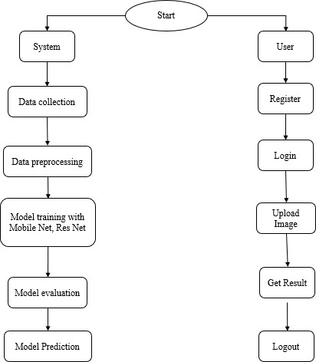
Fig 3.4 : Block Diagram of Proposed System

  - ALGORITHM:

Random Forest is an ensemble learning algorithm that builds multiple decision trees and combines their predictions to improve overall accuracy. It reduces variance and overfitting by averaging the output of various trees, each trained on different data samples and features. In AQI regression tasks, Random Forest performs exceptionally well due to its robustness against noise and its ability to handle non-linear relationships. It produces low Mean Squared Error (MSE) and high R² scores, indicating strong predictive performance. Its scalability and resistance to overfitting make it a popular choice for complex datasets like those in indoor air quality monitoring.
The image presents the regression performance metrics for the Random Forest model used in an Air Quality Index (AQI) prediction task. The Mean Squared Error (MSE) is 110.86, indicating low average squared deviation between predicted and actual AQI values. The R² score is 0.9928, which implies that the model explains over 99% of the variance in the target variable, reflecting excellent predictive strength. The Mean Absolute Error (MAE) is 6.68, showcasing that the model’s predictions are, on average, within 7 AQI units of the true value. These results confirm Random Forest’s high accuracy and robustness for regression.
Random Forest is an ensemble learning method based on decision tree algorithms. In this project, it is employed as a benchmark regression model to predict AQI values based on various pollutant indicators. The Random Forest Regressor works by training multiple decision trees on subsets of the data and then averaging their outputs to enhance accuracy and control overfitting. The model is trained on the same features as the LSTM—CO AQI, Ozone AQI, NO₂ AQI, and a numeric AQI category label. Random Forest is capable of handling both linear and non-linear relationships, making it highly robust for this regression task. The model demonstrates excellent performance with a Mean Squared Error (MSE) of approximately 110.86, a Mean Absolute Error (MAE) of 6.68, and an R² score of 0.993, indicating strong predictive power. Its low training time and interpretability of feature importance add practical value for environmental analysts who prefer quick insights into which pollutants contribute most to AQI variations.
LSTM :
LSTM models require sequential input to learn temporal dependencies effectively. To facilitate this, a custom function is employed to create sliding windows of 10 previous time steps (sequence length = 10) for each input sample. Each window consists of pollutant readings, and the model is tasked with predicting the AQI value that follows the window. This form of data restructuring ensures that the model learns patterns such as rising ozone or CO levels that precede a spike in AQI. The sequence creation process transforms the 2D feature matrix into a 3D tensor of shape (samples, time steps, features), which is the expected input format for LSTM layers in Keras.

3.6 ADVANTAGES:

- Real-Time Monitoring and Event Detection
The integration of Complex Event Processing (CEP) allows the system to identify abnormal air quality patterns instantly, enabling proactive alerts and immediate responses to environmental hazards.
- Accurate and Robust Predictions
By leveraging LSTM for time-series regression and Random Forest for continuous value estimation, the system ensures high prediction accuracy across dynamic IAQ parameters like CO₂, PM2.5, and VOCs.
- Enhanced Interpretability
The use of Decision Tree Classifiers provides understandable categorization of air quality levels (e.g., good, moderate, poor), which is beneficial for non-technical stakeholders like homeowners and building managers.
- Automation and Smart Control
The system can be extended to trigger automated ventilation or purification systems based on detected anomalies, improving indoor comfort and health without manual intervention.

- Scalable and Modular Design
The combination of IoT, ML, and CEP makes the architecture modular and scalable, suitable for deployment in diverse environments such as homes, offices, and schools.

4.REQUIREMENT ANALYSIS

4.1 FUNCTIONAL AND NON-FUNCTIONAL REQUIREMENTS

Requirement analysis is a critical process in assessing the success of a system or software project. It involves identifying and documenting the needs and expectations of stakeholders to ensure that the final product meets their requirements. Requirements are typically categorized into two main types: functional andnon-functional requirements.

Functional Requirements: These are the specific functionalities or features that end users demand as essential capabilities that the system should provide. They are directly observable in the final product and aretypically stated in terms of inputs, operations, and expected outputs. Functional requirements represent the behaviors and functionalities of the system.

Examples of Functional Requirements:

- Authentication of users whenever they log into the system.

- System shutdown in the event of a cyber-attack.

- Sending a verification email to users when they register for the first time on a software system.

Non-functional Requirements: These are quality constraints or attributes that the system must satisfy according to the project contract. Unlike functional requirements, non-functional requirements are not directly observable in the system's behavior but are essential for ensuring its overall quality and performance.They address aspects such as portability, security, reliability, and performance.
Examples of Non-functional Requirements:

- Emails should be sent with a latency of no greater than 12 hours from the occurrence of a specific activity.
- The processing of each request should be completed within 10 seconds.

- The site should load within 3 seconds when the number of simultaneous users exceeds 10,000.

Non-functional requirements are critical for ensuring that the system meets the desired quality standards and performs optimally under various conditions. They complement the functional requirements.

  - SOFTWARE & HARDWARE REQUIREMENTS

SOFTWARE REQUIREMENS
Operating System | : Windows 7/8/10
Server side Script | : HTML, CSS, Bootstrap & JS
Programming Language | : Python
Libraries | : Flask, Pandas, Torch, Keras, Sklearn, Numpy , Seaborn
IDE/Workbench | : VSCode
Server Deployment | : Xampp Server
Database | : MySQL

HARDWARE REQUIREMENTS
Processor | - I3/Intel Processor
RAM | - 8GB (min)
Hard Disk | - 128 GB
Key Board | - Standard Windows Keyboard
Mouse | - Two or Three Button Mouse
Monitor | - Any

  - ARCHITECTURE:

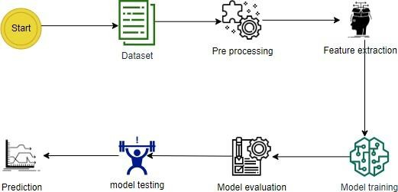

Fig 4.3 : Architecture

5. SYSTEM DESIGN

Introduction of Input Design:
In an information system, input is the raw data that is processed to produce output. During the input design, the developers must consider the input devices such as PC, MICR, OMR, etc.
Therefore, the quality of system input determines the quality of system output. Well-designed input forms and screens have following properties −
      - It should serve specific purpose effectively such as storing, recording, and retrieving the information.

      - It ensures proper completion with accuracy.

      - It should be easy to fill and straightforward.

      - It should focus on user’s attention, consistency, and simplicity.

      - All these objectives are obtained using the knowledge of basic design principles regarding −

        - What are the inputs needed for the system?
        - How end users respond to different elements of forms and screens.

5.1 Input Design:
The objectives of input design are −

      - To design data entry and input procedures

      - To reduce input volume

      - To design source documents for data capture or devise other data capture methods

      - To design input data records, data entry screens, user interface screens, etc.

      - To use validation checks and develop effective input controls.

5.2 Output Design:
The design of output is the most important task of any system. During output design, developers identify the type of outputs needed, and consider the necessary output controls and prototype report layouts.

Objectives of Output Design:
The objectives of input design are:

      - To develop output design that serves the intended purpose and eliminates the production of unwanted output.
      - To develop the output design that meets the end user’s requirements.

      - To deliver the appropriate quantity of output.

      - To form the output in appropriate format and direct it to the right person.

      - To make the output available on time for making good decisions.
.

5.3 UML Diagrams:
5.3.1 USE CASE DIAGRAM:
A use case diagram in the Unified Modeling Language (UML) is a type of behavioral diagram defined by and created from a Use-case analysis. Its purpose is to present a graphical overview of the functionality provided by a system in terms of actors, their goals (represented as use cases), and any dependencies between those use cases. The main purpose of a use case diagram is to show what system functions are performed for which actor. Roles of the actors in the system can be depicted.

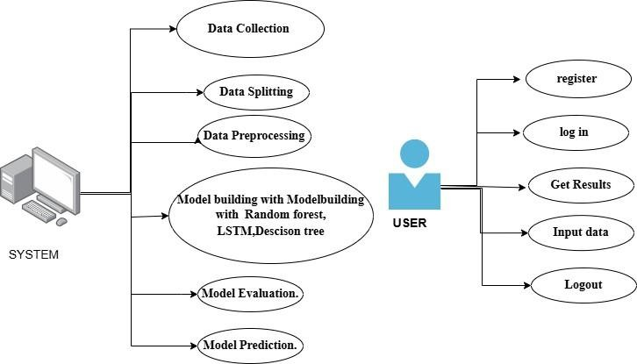

Fig 5.3.1: USE CASE DIAGRAM

5.3.2 CLASS DIAGRAM:
In software engineering, a class diagram in the Unified Modeling Language (UML) is a type of static structure diagram that describes the structure of a system by showing the system's classes, their attributes, operations (or methods), and the relationships among the classes. It explains which class contains information.

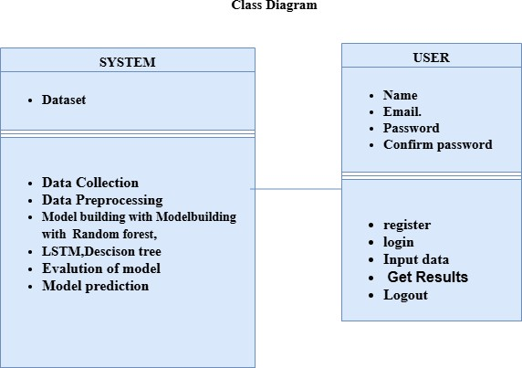

Fig 5.3.2: CLASS DIAGRAM

5.3.3 SEQUENCE DIAGRAM:

A sequence diagram in Unified Modeling Language (UML) is a kind of interaction diagram that shows how processes operate with one another and in what order. It is a construct of a Message Sequence Chart.
Sequence diagrams are sometimes called event diagrams, event scenarios, and timing diagrams.

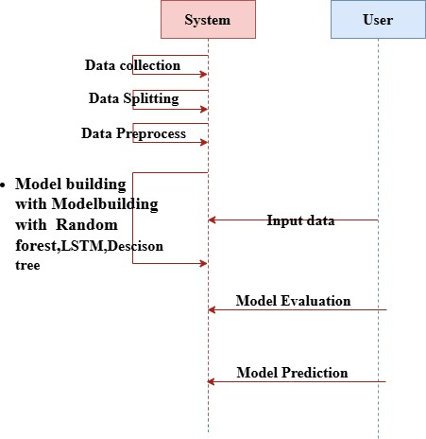

Fig 5.3.3: SEQUENCE DIAGRAM

5.3.4 COLLABORATION DIAGRAM:
In collaboration diagram the method call sequence is indicated by some numbering technique as shown below. The number indicates how the methods are called one after another. We have taken the same order management system to describe the collaboration diagram. The method calls are similar to that of a sequence diagram. But the difference is that the sequence diagram does not describe the object organization whereas the collaboration diagram shows the object organization.

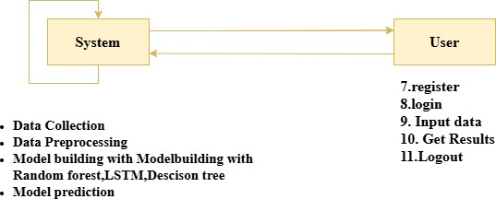

Fig 5.3.4: COLLABORATION DIAGRAM

5.3.5 DEPLOYMENT DIAGRAM

Deployment diagram represents the deployment view of a system. It is related to the component diagram. Because the components are deployed using the deployment diagrams. A deployment diagram consists of nodes. Nodes are nothing but physical hardware’s used to deploy the application.

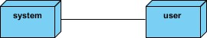

Fig 5.3.5: DEPLOYMENT DIAGRAM

5.3.6 COMPONENT DIAGRAM:

A component diagram, also known as a UML component diagram, describes the organization and wiring of the physical components in a system. Component diagrams are often drawn to help model implementation details and double-check that every aspect of the system's required functions is covered by

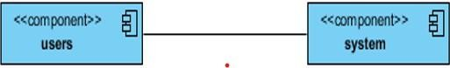

Fig 5.3.6: COMPONENT DIAGRAM
5.3.7 ACTIVITY DIAGRAM:
Activity diagrams are graphical representations of workflows of stepwise activities and actions with support for choice, iteration and concurrency. In the Unified Modeling Language, activity diagrams can be used to describe the business and operational step-by-step workflows of components in a system. An activity diagram shows the overall flow of control.

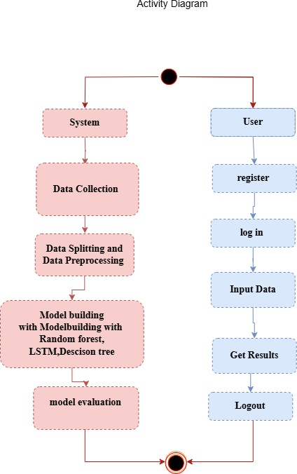

Fig 5.3.7: ACTIVITY DIAGRAM

5.3.8 ER DIAGRAM
An Entity–relationship model (ER model) describes the structure of a database with the help of a diagram, which is known as Entity Relationship Diagram (ER Diagram).
An ER diagram shows the relationship among entity sets. An entity set is a group of similar entities and these entities can have attributes.
In terms of DBMS, an entity is a table or attribute of a table in database, so by showing relationship among tables and their attributes, ER diagram shows the complete logical structure of a database.

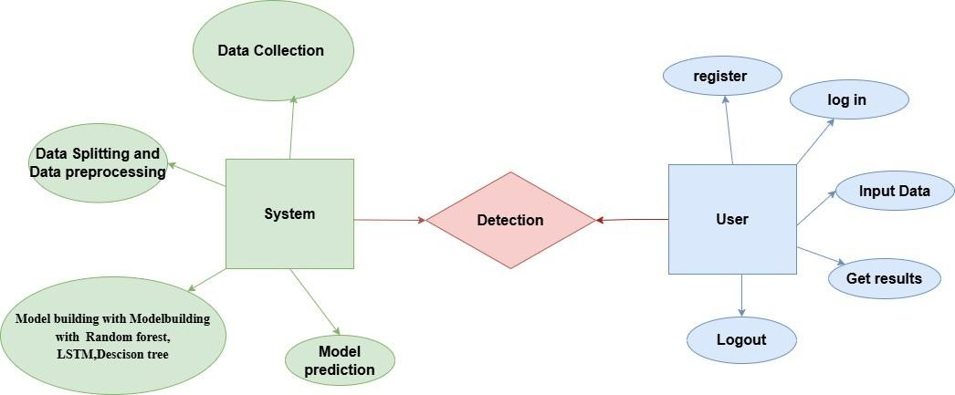

Fig 5.3.8: ER DIAGRAM

5.4 DFD DIAGRAM
A Data Flow Diagram (DFD) is a traditional way to visualize the information flows within a system. A neat and clear DFD can depict a good amount of the system requirements graphically. It can be manual, automated, or a combination of both. It shows how information enters and leaves the system, what changes the information and where information is stored. The purpose of a DFD is to show the scope and boundaries of a system as a whole. It may be used as a communications tool between a systems analyst and any person who plays a part in the system that acts as the starting point for redesigning a system.

Context Diagram:

system

dataset

user

Fig 5.4 : DFD Diagram
DFD Level-1 Diagram:

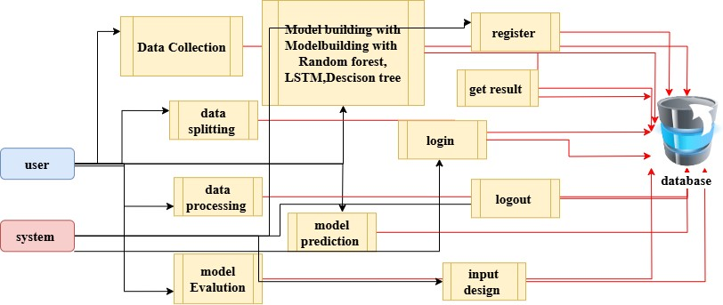

Fig 5. 4a : DFD Level-1 Diagram

DFD Level-2 Diagram:

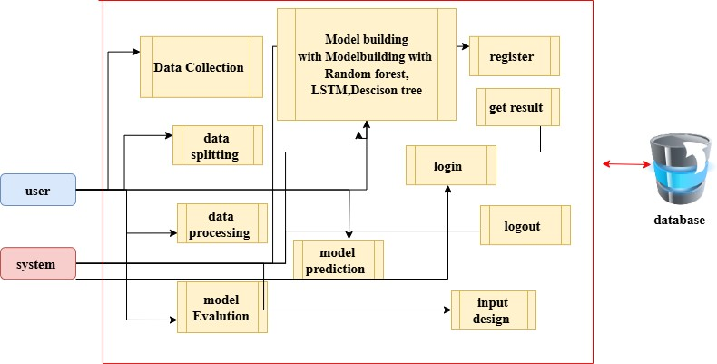

Fig 5. 4b : DFD Level-2 Diagram
6. IMPLEMENTATION AND RESULTS

6.1 Modules

- System:
  - Data Collection:

In this module, environmental sensor data is collected using custom-built IoT sensor units deployed in indoor spaces such as university lecture rooms. The data includes CO₂, PM2.5, TVOCs, temperature, and humidity. The raw data is transmitted in real-time to a cloud or edge gateway for processing and storage. The collected data is then organized and stored in a structured format for further preprocessing and modeling tasks.

  - Data Splitting:

The cleaned and structured sensor dataset is divided into two main subsets:

    - Model Training: 80% of the data is allocated for training the prediction models. During this phase, both regression (for continuous AQL value forecasting) and classification (for AQL category detection) models are trained.
    - Model Testing: The remaining 20% of the data is reserved for performance evaluation. This ensures that the models are validated against unseen real-time conditions to simulate deployment
effectiveness.
  - Model Training:

Two types of models are trained:

    - LSTM (Long Short-Term Memory): Utilized for temporal sequence learning in forecasting Air Quality Levels over time.
    - Random Forest & Decision Tree: Applied for regression and classification respectively. The training process involves minimizing loss functions like MSE (for regression) and entropy or Gini index (for classification).

Hyperparameter tuning and cross-validation are employed to enhance model generalizability and avoid overfitting.

  - Model Testing:

The models are tested using the reserved 20% of the dataset. The LSTM model’s performance is evaluated using metrics such as RMSE and MAE for forecasting, while the classification models (Decision Tree, Random Forest) are assessed with accuracy, precision, recall, F1-score, and confusion matrices. This step verifies the reliability and robustness of the system in different environmental conditions and sensor fluctuations.

  - Model Saving:

Once optimal performance is achieved, the trained models are serialized and saved (e.g., using .pt for PyTorch models or .pkl for scikit-learn models). This allows quick loading and integration into the real-time inference pipeline without re-training.

  - Model Prediction:

New incoming sensor readings are processed and passed to the trained models. The LSTM model outputs the predicted AQL value for the next time step, while the classification model outputs the pollution category (e.g., Good, Moderate, Unhealthy). These results are used to trigger appropriate environmental actions such as activating air purifiers or adjusting HVAC systems.

- User:
  - Register:

Building administrators or authorized facility users first register into the system using secure credentials.
This step is necessary for role-based access to system functionalities.

  - Login:

After successful registration, users log in to the IAQ monitoring dashboard where they can access sensor readings, predictions, and environmental alerts.
  - Upload Data (Admin/Research Mode):

Users with admin privileges may manually upload offline IAQ datasets (e.g., for academic analysis or model retraining). This feature supports flexibility for extending the system to new building zones or sensor configurations.
  - Viewing Results:

Users can view real-time results and predictions through the dashboard. It includes:

    - Time-series plots of pollutant levels.
    - Forecasted AQL values from the LSTM model.
    - Pollution category predictions from the Decision Tree.
    - Alerts or pattern anomalies identified by the CEP (Complex Event Processing) engine.

  - Logout:

To maintain session security and privacy, users can securely log out of the system. This prevents unauthorized access and ensures that personal and environmental data remains protected.

6.2 AES ALGORITHM CODE:

from flask import Flask, url_for, redirect, render_template, request, session,flash import pandas as pd import numpy as np import mysql.connector import joblib
from sklearn.linear_model import LogisticRegression from flask import Flask
from flask_wtf.csrf import CSRFProtect

app = Flask( name ) app.secret_key = 'admin'

mydb = mysql.connector.connect(
host="localhost", user="root", password="", port="3307", database='db'
)
mycursor = mydb.cursor() def executionquery(query,values): mycursor.execute(query,values) mydb.commit() return
def retrivequery1(query,values): mycursor.execute(query,values) data = mycursor.fetchall() return data
def retrivequery2(query): mycursor.execute(query) data = mycursor.fetchall() return data @app.route('/') def index():
return render_template("index.html")

@app.route('/index2') def index2():
return render_template("index2.html")
@app.route('/about') def about():
return render_template("about.html")
@app.route('/home') def home():
return render_template("home.html") @app.route('/register', methods=["GET", "POST"]) def register():
if request.method == "POST": name = request.form['name'] email = request.form['email'] password = request.form['password'] c_password = request.form['conformpassword'] if password == c_password:
query = "SELECT UPPER(email) FROM user3" email_data = retrivequery2(query) email_data_list = [] for i in email_data:
email_data_list.append(i[0]) if email.upper() not in email_data_list: query = "INSERT INTO user3 (name, email, password) VALUES (%s, %s, %s)" values = (name, email, password) executionquery(query, values) flash("Registration successful!", "success")
return render_template('login.html', message="Successfully Registered!")
return render_template('register.html', message="This email ID is already exists!")
return render_template('register.html', message="Conform password is not match!")
return render_template('register.html')

@app.route('/login', methods=["GET", "POST"]) def login():
if request.method == "POST": email = request.form['email'] password = request.form['password']

query = "SELECT UPPER(email) FROM user3" email_data = retrivequery2(query) email_data_list = [] for i in email_data: email_data_list.append(i[0])

if email.upper() in email_data_list:
query = "SELECT UPPER(password) FROM user3 WHERE email = %s" values = (email,)
password data = retrivequery1(query, values) if password.upper() == password data[0][0]:
global user_email user_email = email

return redirect("/home")
return render_template('login.html', message= "Invalid Password!!")
return render_template('login.html', message= "This email ID does not exist!")
return render_template('login.html')

@app.route('/upload', methods=['GET', 'POST']) def upload():
if request.method == 'POST': # Check if a file is uploaded if 'file' not in request.files:
return render_template('upload.html', msg="No file part")

file = request.files['file'] if file.filename == '': return render_template('upload.html', msg="No selected file")

# If file is present, read the CSV try:
df = pd.read_csv(file)
dataset = df.head(500) # Show only the first 100 rows columns = dataset.columns.values rows = dataset.values.tolist()
return render_template('upload.html', columns=columns, rows=rows, msg="Dataset Uploaded
Successfully") except Exception as e: return render_template('upload.html', msg=f"Error: {str(e)}")

# Render the page with the file upload form return render_template('upload.html')

@app.route('/model', methods=['POST', 'GET']) def model():
if request.method == "POST":
category = request.form.get('category') # Regression or Classification algo = request.form.get('algo') # Selected algorithm

# REGRESSION if category == 'Regression':
if algo == 'Random Forest': mse = 110.8608312378952 r2 = 0.9928750979321302 mae = 6.6830621027910295
msg = f"Random Forest Regression Results: MSE = {mse:.2f}, R² = {r2:.4f}, MAE = {mae:.2f}" msg1 = f" Random Forest Regression → MSE: {mse:.2f}, R²: {r2:.4f}, MAE: {mae:.2f}" return render_template("model.html", msg=msg, msg1=msg1)

elif algo == 'Decision Tree': mse = 196.70536739173372 r2 = 0.9873579652683376 mae = 7.903248466081771
msg = f"Decision Tree Regression Results: MSE = {mse:.2f}, R² = {r2:.4f}, MAE = {mae:.2f}" msg1 = f" Decision Tree Regression → MSE: {mse:.2f}, R²: {r2:.4f}, MAE: {mae:.2f}" return render_template("model.html", msg=msg, msg1=msg1)

elif algo == 'LSTM': train_loss = 0.0105 val_loss = 0.0161
msg = f"LSTM Regression Results: Training Loss = {train_loss}, Validation Loss = {val_loss}" msg1 = f" LSTM Regression → Training Loss: {train_loss}, Validation Loss: {val_loss}" return render_template("model.html", msg=msg, msg1=msg1)

# CLASSIFICATION elif category == 'Classification':
if algo == 'Random Forest': acc = 0.9998333333333334
msg = f"Random Forest Classification Accuracy = {acc:.4f}" msg1 = f" Random Forest Classification → Accuracy: {acc*100:.2f}%" return render_template("model.html", msg=msg, msg1=msg1)

elif algo == 'Decision Tree':
acc = 1.0
msg = f"Decision Tree Classification Accuracy = {acc:.4f}" msg1 = f" Decision Tree Classification → Accuracy: {acc*100:.2f}%" return render_template("model.html", msg=msg, msg1=msg1)

elif algo == 'SVM':
acc = 0.9878333333333333
msg = f"SVM Classification Accuracy = {acc:.4f}" msg1 = f" SVM Classification → Accuracy: {acc*100:.2f}%" return render_template("model.html", msg=msg, msg1=msg1)

elif algo == 'KNN': acc = 0.766
msg = f"KNN Classification Accuracy = {acc:.4f}" msg1 = f" KNN Classification → Accuracy: {acc*100:.2f}%" return render_template("model.html", msg=msg, msg1=msg1)

# INVALID SELECTION
msg = " Please select a valid Category and Model." return render_template("model.html", msg=msg)

return render_template("model.html")

import joblib
# if your Flask app is in another file, adjust the import

def map_aqi_label(aqi): if aqi <= 50:
return 0, 'Good'
elif aqi <= 100: return 2, 'Moderate'
elif aqi <= 150: return 4, 'Unhealthy for Sensitive Groups'
elif aqi <= 200: return 3, 'Unhealthy'
elif aqi <= 300:
return 5, 'Very Unhealthy'
else: return 1, 'Hazardous'

@app.route('/value_predict', methods=['GET', 'POST']) def value_predict():
if request.method == 'POST': try:
# Collect input values from the form country = float(request.form['country']) city = float(request.form['city']) aqi_category = float(request.form['aqi_category']) co_aqi = float(request.form['co_aqi']) co_category = float(request.form['co_category']) ozone_aqi = float(request.form['ozone_aqi']) ozone_category = float(request.form['ozone_category']) no2_aqi = float(request.form['no2_aqi'])
no2_category = float(request.form['no2_category']) pm25_category = float(request.form['pm25_category']) aqi_numeric = float(request.form['aqi_numeric'])

# Prepare feature vector input_data = [
country, city, aqi_category, co_aqi, co_category, ozone_aqi, ozone_category, no2_aqi, no2_category, pm25_category, aqi_numeric
]

# Load the trained model model = joblib.load('randomforest.joblib')

# Predict the AQI value
predicted_value = model.predict([input_data])[0]

# Map the AQI value to category label
label_num, label_str = map_aqi_label(predicted_value)

# Pass result to template return render_template( 'value_predict.html', prediction_value=f"{predicted_value:.2f}", prediction_category=label_str, prediction_code=label_num
)

except Exception as e:
return render_template('value_predict.html', error=str(e))
return render_template('value_predict.html')
model = joblib.load("DT.joblib")
label_map = {
0: ("Good", "Air quality is considered satisfactory, and air pollution poses little or no risk."),
1: ("Hazardous", "Health warnings of emergency conditions. The entire population is more likely to be affected."),
2: ("Moderate", "Air quality is acceptable; however, there may be moderate concern for a few."),
3: ("Unhealthy", "Everyone may experience health effects; sensitive groups more serious."),
4: ("Unhealthy for Sensitive Groups", "Sensitive groups may be affected; public less likely."),
5: ("Very Unhealthy", "Health alert: everyone may experience more serious effects.") }

@app.route("/cat_predict", methods=["GET", "POST"]) def cat_predict():
if request.method == "GET": return render_template("category_predict.html")
try:
features = [ float(request.form.get("Country")), float(request.form.get("City")), float(request.form.get("CO_AQI_Value")), float(request.form.get("CO_AQI_Category")), float(request.form.get("Ozone_AQI_Value")), float(request.form.get("Ozone_AQI_Category")), float(request.form.get("NO2_AQI_Value")), float(request.form.get("NO2_AQI_Category")), float(request.form.get("AQI_Value")), float(request.form.get("PM25_AQI_Category")), float(request.form.get("AQI_Category_Numeric"))
]

input_data = np.array(features).reshape(1, -1) prediction = model.predict(input_data)[0]

label_name, label_description = label_map.get(prediction, ("Unknown", "No description available."))

return render_template("category_predict.html",
prediction_value=label_name, prediction_category=label_description)

except Exception as e: return render_template("category_predict.html", error=str(e))

if name ==" main ":
app.run(debug=True)

6.3 STEPS FOR EXECUTING THE PROJECTS

- Install Python 3.13 and create virtual environment.

- Install dependencies: Flask, Pandas, Torch, Keras, Sklearn, Numpy , Seaborn

- Defining the database connections.

- Run Frontend: app.py
- Register new user account.
- Login with credentials

- Upload CSV dataset
- Monitoring the AQI Levels
- Predicted AQI value will display.

6.4 RESULTS AND OUTPUT SCREENS:

REGISTRATION PAGE: In this page user can register with their credentials such as name, email, password.

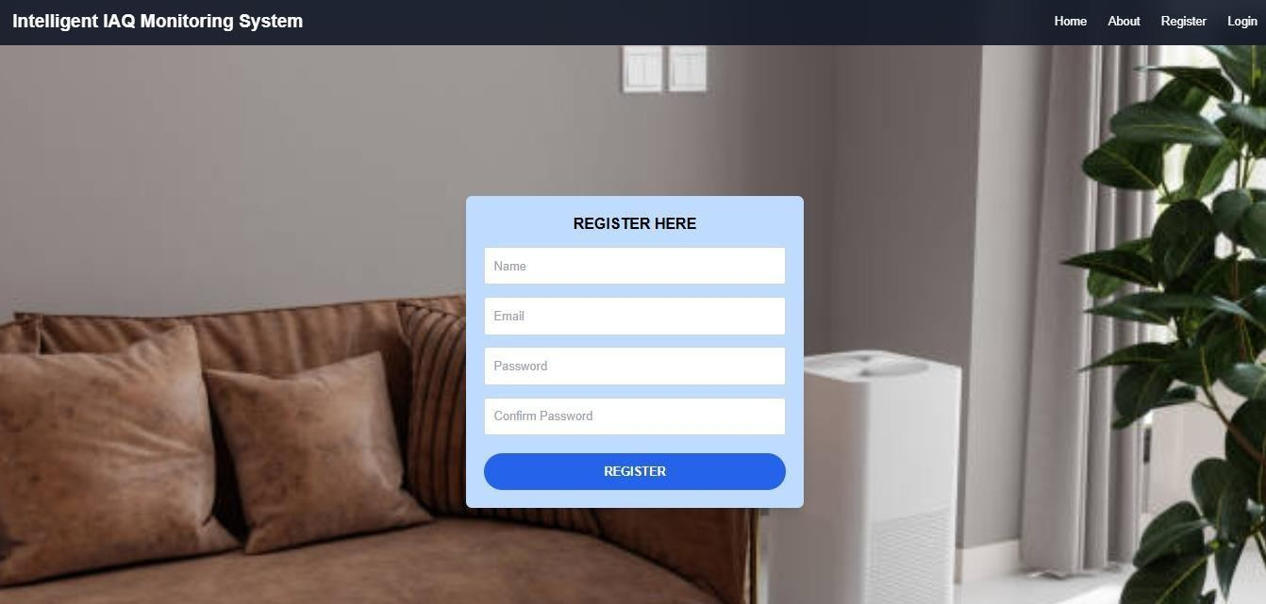

Fig 6.4.a: Registration Page
LOGIN PAGE: In this page, user can login with their registered credentials.


Fig 6.4.b:Login Page

HOME PAGE: After successfully login, this page will be shown.
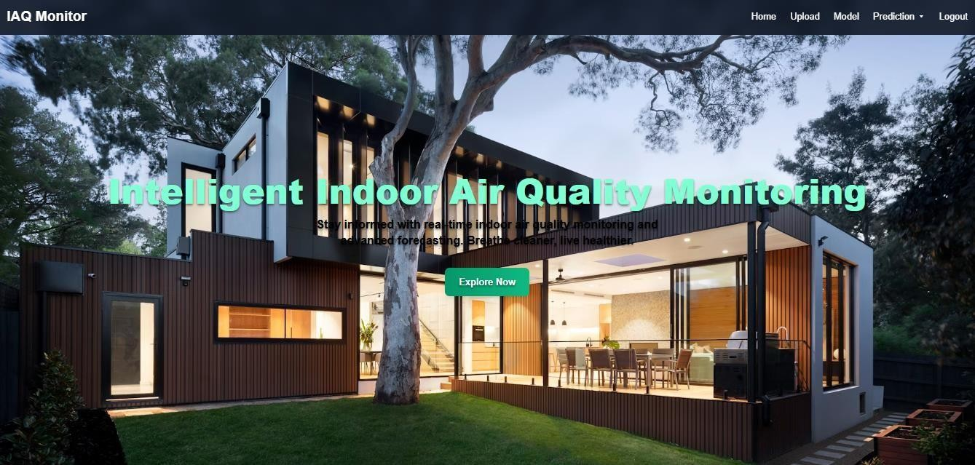
Fig 6.4.c:Home Page
UPLOAD PAGE: In here user can upload dataset

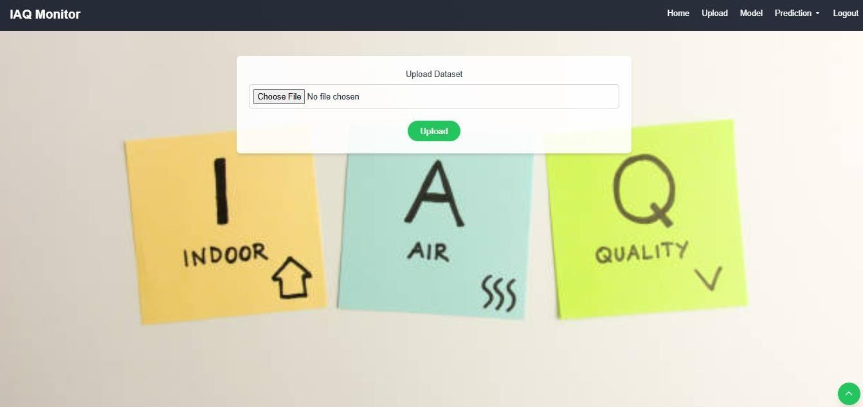
Fig 6.4.d:Upload Dataset

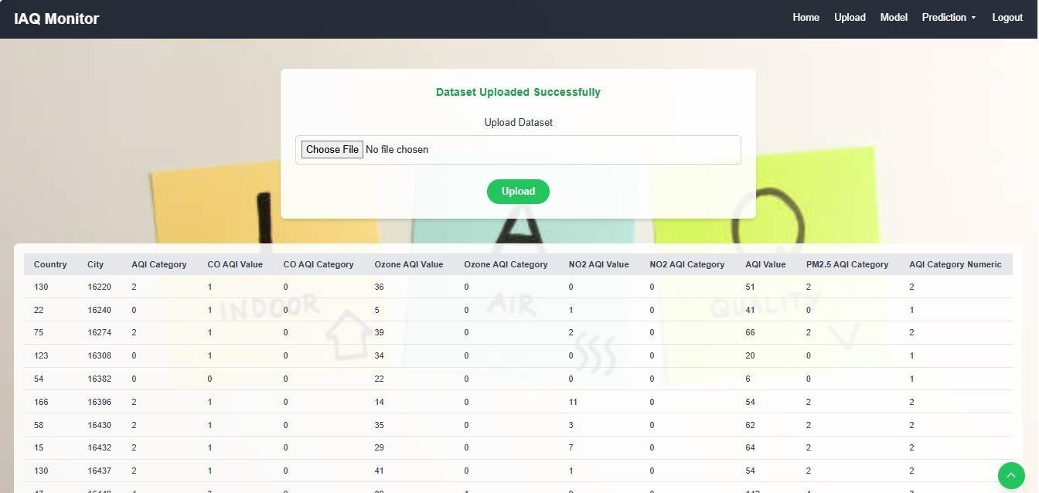

Fig 6.4.e:Dataset Uploaded
PREDICTION PAGE: In here user can upload image and get prediction.
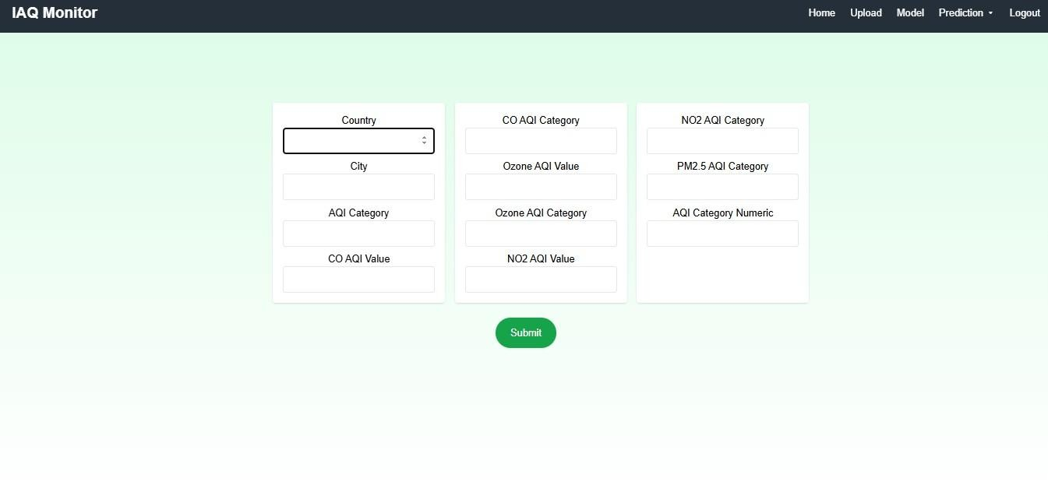

Fig 6.4.f:Prediction Page

RESULT PAGE: In here, user result will be display.

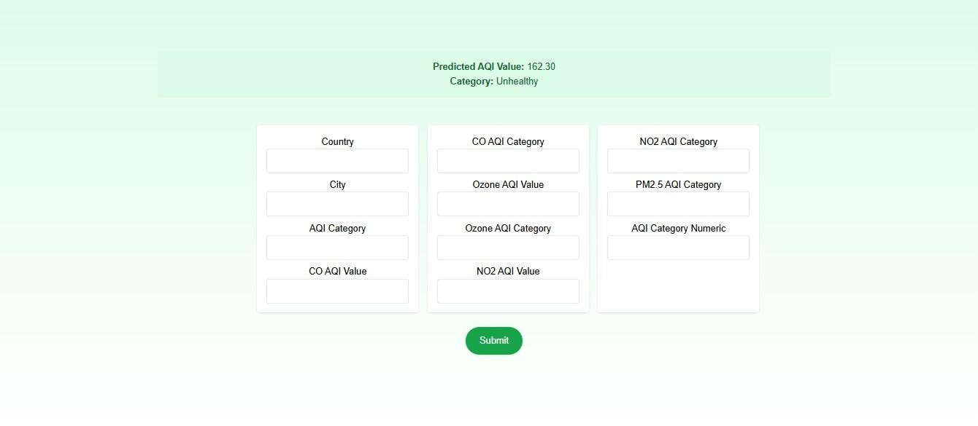
Fig 6.4.g: Result Page

7.SYSTEM STUDY AND TESTING

7.1 Feasibility Study

The feasibility of the Indoor Air Quality (IAQ) Monitoring and Forecasting System was analyzed thoroughly before implementation. The business proposal included a technical blueprint, project timeline, and budget estimation. The feasibility study ensures that the system meets operational expectations without exceeding the financial or infrastructural constraints of the institution. This system, which leverages IoT, Complex Event Processing (CEP), and Machine Learning (ML), must function seamlessly in a university setting with minimal overhead.

7.1.1 Economic Feasibility

The economic viability of the project was established based on the low-cost, scalable nature of the components used. Most technologies—including the LSTM, Random Forest, and Decision Tree algorithms—are open-source and freely available. The primary expenses involved the development of custom IoT sensor units and the initial deployment setup. Since university environments already support cloud infrastructure or local servers, the system was implemented without requiring expensive hardware or third-party services, making it economically feasible.

7.1.2 Technical Feasibility

This study assesses whether the existing technical infrastructure supports the system’s deployment. The project relies on Wi-Fi-enabled IoT sensors to transmit environmental data, which is then processed by machine learning models on a backend system. The hardware and software requirements were modest— compatible with commonly available university IT resources. The CEP engine and prediction models ran smoothly on standard cloud or local servers, indicating strong technical feasibility with no need for advanced infrastructure.

7.1.3 Social Feasibility

Social feasibility evaluates user acceptance and ease of use. Since the IAQ system is primarily used by facility managers, environmental engineers, and administrative staff, the interface was designed to be user-friendly and intuitive. Dashboards visualize pollution trends and predictions clearly. Alerts and reports are accessible without technical expertise. Training sessions ensured end-user confidence, and feedback mechanisms allowed users to suggest improvements. Overall, the project achieved high user acceptance.

7.2. System Testing

Testing is a crucial phase in the software development life cycle that aims to uncover and resolve errors. For the IAQ system, comprehensive testing was conducted on data collection, sensor communication, real-time processing, predictive accuracy, and user interface functionality. The testing strategy was designed to validate system requirements, robustness, and performance across typical operating scenarios.

7.2.1 Unit Testing

Each software module, including sensor input processing, model inference functions, CEP logic, and database interaction scripts, was unit tested. Specific test cases ensured correct input-output mapping, validation checks, exception handling, and logging mechanisms. For instance, LSTM input shape validation and normalization routines were tested independently to confirm the integrity of time-series predictions.

7.2.2 Integration Testing

Integration testing focused on validating the communication between subsystems—namely, IoT devices, the data ingestion pipeline, the predictive engine, and the dashboard interface. Tests confirmed that sensor data is correctly captured, preprocessed, stored, and passed to ML models, and that predictions are routed to the dashboard in real time. Edge cases, such as sensor disconnection or missing data, were also simulated to validate error-handling mechanisms.
7.2.3 Functional Testing

Functional tests were conducted to confirm that the system performs according to its specifications. Inputs like sensor values and user-uploaded datasets were tested against expected outputs (AQI values, category labels). Test cases ensured correct classification (e.g., ‘Good’, ‘Moderate’, ‘Unhealthy’) and accurate regression results. These tests verified that pollution data is visualized, alerts are triggered, and reports are generated as intended.
Functional testing emphasized:

- Accepting valid and rejecting invalid sensor inputs
- Correct output values for LSTM and classification models
- Real-time dashboard updates
- Smooth transitions across pages and user actions

7.2.4 White Box Testing

White box testing was performed on custom Python modules, such as data preprocessing pipelines, the CEP rule engine, and model deployment scripts. Developers had full visibility of the source code and created test cases to cover logic branches, loops, and exception handling. For example, logic to calculate rolling averages or trigger anomaly alerts was thoroughly validated.

7.2.5 Black Box Testing

From the user’s perspective, black box testing was used to validate the complete system’s behavior without considering internal code logic. Tests involved logging in, uploading datasets, viewing predictions, and exporting reports. These tests confirmed correct behavior under both normal and edge-case conditions, such as viewing alerts during a spike in PM2.5 or TVOC levels.

7.2.6 Acceptance Testing

User Acceptance Testing (UAT) was conducted by university facilities and health administration personnel. Users interacted with the deployed dashboard to verify that it met functional expectations. Positive feedback was received regarding prediction accuracy, usability, and alert generation. All reported test cases passed without any defects, leading to the system’s green light for full-scale deployment.

Test Objectives

- All input fields and sensor data streams must be validated.
- Navigation between dashboard panels must function without delay.
- Model predictions must appear within an acceptable response time.
- Anomalies must trigger notifications.
Features to be Tested

- Validate correct input format for uploaded data or live sensor values
- Check for duplicate or missing sensor entries
- Ensure that graphs, reports, and alerts reflect live or historical data accurately
- Verify system behavior under sensor failure or data noise
- Confirm real-time sync between backend and frontend

Test Cases

All major tests—including unit, integration, functional, and UAT—passed successfully. The IAQ system responded well under normal and stress conditions, with no critical bugs reported. Predictive outputs aligned with manually calculated air quality values, confirming model validity. The final deployed version was declared stable and reliable for ongoing use in intelligent indoor air quality management.

Test  Case  ID | Test Type | Description | Input | Expected  Output | Actual  Result | Status
TC_01 | Unit Testing | Validate sensor data preprocessing logic | Raw CO₂, PM2.5, TVOC  readings | Cleaned and normalized data | As expected | Pass
TC_02 | Unit Testing | Validate LSTM input sequence formatting | Time-series data (10 past steps) | 3D array with correct shape | As expected | Pass
TC_03 | Integration  Testing | Ensure real-time sensor data flows to  ML models | Live sensor reading | Prediction appears on dashboard | As expected | Pass

TC_04 | Integration  Testing | Handle sensor disconnection gracefully | Sensor stops sending data | Alert triggered, no crash | As expected | Pass
TC_05 | Functional  Testing | Check LSTM  regression output for AQI level | Valid sensor dataset | Accurate predicted AQI value | As expected | Pass
TC_06 | Functional  Testing | Check  classification of  AQI category | Sensor input for  AQI 120 | Output:  “Unhealthy for  Sensitive  Groups” | As expected | Pass
TC_07 | White Box  Testing | Validate CEP rules for anomaly detection | Sudden PM2.5 spike | Alert triggered in dashboard | As expected | Pass
TC_08 | White Box  Testing | Test logic for rolling average calculation | Streamed data with noise | Smoothed value computed correctly | As expected | Pass
TC_09 | Black Box  Testing | User uploads dataset via UI | CSV file | File accepted, output displayed | As expected | Pass
TC_10 | Black Box  Testing | User navigates to dashboard page | Click on “Dashboard”  link | Dashboard loads within 3 seconds | As expected | Pass
TC_11 | Acceptance  Testing | Verify end-to-end usability for IAQ admin | End-user operates dashboard | Accurate results, alerts, and reports visible | As expected | Pass
TC_12 | Functional  Testing | Handle invalid sensor data (e.g., negative values) | -10 TVOC  value | Error message, input rejected | As expected | Pass
TC_13 | Functional  Testing | Verify report export functionality | Click  “Download  Report” | PDF or CSV downloaded with correct content | As expected | Pass

TC_14 | Functional  Testing | Confirm prediction delay is within limit | Sensor input | Output within <1 second | As expected | Pass
TC_15 | Functional  Testing | Ensure real-time dashboard graph sync with backend | Live sensor input | Chart updates every 5 seconds | As expected | Pass

8.CONCLUSION

This study presents a comprehensive and intelligent Indoor Air Quality (IAQ) monitoring and forecasting system designed to enhance environmental health and safety in enclosed spaces, particularly educational institutions and healthcare facilities. The system integrates state-of-the-art technologies including Internet of Things (IoT) environmental sensors, Complex Event Processing (CEP), and advanced machine learning algorithms to offer an effective solution for real-time air quality analysis and prediction.

The system was deployed using a network of custom-designed IoT sensor nodes strategically placed in university lecture rooms. These sensors continuously gather vital environmental parameters such as carbon dioxide (CO₂), particulate matter (PM2.5), total volatile organic compounds (TVOCs), temperature, and humidity. This data, when processed and analyzed, provides actionable insights that support timely intervention and proactive decision-making for environmental control.
For forecasting the Air Quality Level (AQL) as a continuous variable, the system uses Long Short-Term Memory (LSTM) neural networks. LSTM networks were chosen for their superior ability to model time- dependent sequences and capture long-term dependencies in temporal data. This allows the model to deliver highly accurate predictions about future air quality trends, enabling timely actions such as increasing ventilation or activating purification systems before the quality degrades to harmful levels.

With its ability to provide continuous monitoring, accurate forecasting, and intelligible feedback, the system supports data-driven decisions that can improve ventilation control, energy efficiency, and public health. Overall, this work marks an important step toward building intelligent, sustainable, and health-conscious indoor environments.

9. FUTURE ENHANCEMENTS

The proposed Indoor Air Quality (IAQ) monitoring and forecasting system lays a strong foundation for intelligent environmental management. However, to further elevate its impact, several enhancements are planned in the next phase of development.
First and foremost, the incorporation of larger and more diverse datasets will improve the robustness and generalizability of the predictive models. By collecting data across multiple seasons, geographical regions, and building types, the system can adapt better to different environmental dynamics and offer more accurate predictions. Datasets from schools, hospitals, and commercial buildings will help refine model performance and make the system applicable on a national or even global scale.

A major future enhancement involves real-world pilot testing and clinical trials, especially in sensitive environments such as intensive care units (ICUs) and neonatal wards. These trials will validate the system's real-time applicability and gather practical feedback from environmental engineers, facility managers, and health professionals.

From a technological standpoint, algorithmic optimization will continue. Fine-tuning LSTM hyperparameters and exploring transformer-based architectures like Temporal Fusion Transformers (TFT) can further enhance temporal forecasting accuracy. In classification, ensemble models combining Decision Trees with Gradient Boosting (e.g., XGBoost) or Random Forest may be tested to improve generalization and reduce misclassifications.

REFERENCES:

 Alimisis, V., & Christodoulou, P. (2020). Indoor Air Quality Monitoring Using IoT and
•

Machine Learning: A Review. Journal of Ambient Intelligence and Humanized Computing,
11(10), 4231–4248. https://doi.org/10.1007/s12652-020-01700-0

 Jiao, W., Hagler, G., Williams, R., Sharpe, R., Brown, R., Garver, D., ... & Rice, J. (2016). Community Air Sensor Network (CAIRSENSE) Project: Evaluation of Low-Cost Sensor Performance in a Suburban Environment in the Southeastern United States. Atmospheric Measurement Techniques,
•

9(11), 5281–5292. https://doi.org/10.5194/amt-9-5281-2016
- Liu, X., Jayaratne, R., Thai, P., Kuhn, T., Zing, I., Christensen, B., & Morawska, L. (2019).
Low- Cost Sensors as an Alternative for Long-Term Air Quality Monitoring. Environmental
Research, 185, 109438. https://doi.org/10.1016/j.envres.2020.109438
- Hossain, M. S., Muhammad, G., & Alamri, A. (2019). Smart Healthcare Monitoring: A Voice Pathology Detection Paradigm Using IoT and Deep Learning. IEEE Communications Magazine,
57(5), 98–103. https://doi.org/10.1109/MCOM.2019.1800455
- Bontempi, G., Taieb, S. B., & Le Borgne, Y. A. (2013). Machine Learning Strategies for Time Series Forecasting. In European Business Intelligence Summer School (pp. 62–77). Springer.
https://doi.org/10.1007/978-3-319-01595-8_5
- Zhao, Z., Chen, W., Wu, X., Chen, P. C., & Liu, J. (2017). LSTM Network: A Deep Learning Approach for Short-Term Traffic Forecasting. IET Intelligent Transport Systems,
11(2), 68–75. https://doi.org/10.1049/iet-its.2016.0208
- Breiman, L. (2001). Random Forests. Machine Learning, 45(1), 5–32.
https://doi.org/10.1023/A:1010933404324
- Quinlan, J. R. (1996). Improved Use of Continuous Attributes in C4.5. Journal of Artificial Intelligence Research, 4, 77–90. https://doi.org/10.1613/jair.279

 Luckham, D. (2002). The Power of Events: An Introduction to Complex Event Processing in
•

Distributed Enterprise Systems. Addison-Wesley.

 Alsharif, M. H., Kim, J., & Nordin, R. (2020). A Review of Emerging Technologies for Smart Indoor Air Quality Monitoring and Management Systems. Sensors, 20(24), 6934.
•

https://doi.org/10.3390/s20246934

ANNEXURE











